LECHLADE ART SOCIETY

“A DAY DRAWING AND PAINTING IN AND AROUND INGLESHAM CHURCH”

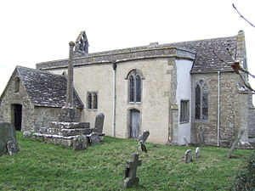

WEDNESDAY, 25TH JUNE 9.30 am – 4.00 pm
Jane Rutherford ACR will give a talk about this ancient church at 10.00 am
All members of the Society and the public are welcome
cost £2 per person

For further details Tel. 01367 252540

