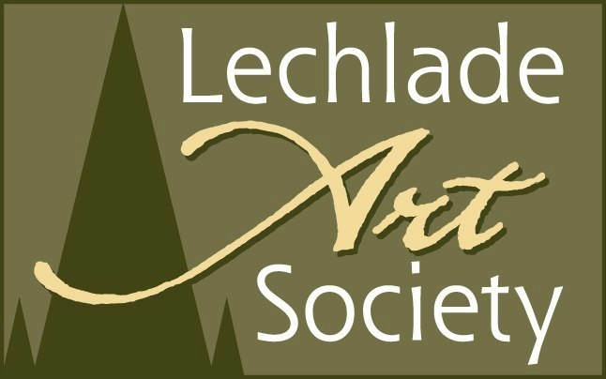

**Newsletter November 2013**

Have you noticed? Autumn is rapidly progressing into Winter – everywhere you look you will inevitably see tinsel and snowflakes heralding the approach of “the Festive Season”- even we, your committee are guilty of this!

We are hoping that there will be a good response to our Christmas Auction and Buffet in December. It should prove to be a lot of fun and a good fund-raiser for your Society. Please respond to the “e flyer” that was sent out last week and send your response to Val Mackenzie. Please contact a member of the committee if you need further details

It’s also at this time of the year that we start planning the Programme of Events for the next year.

For 2013 we tried a different approach and invited some of the home-grown talent and expertise from amongst our members to give us demonstrations and talks: thank you very much again to Jenny, CJ, and Brian. This was well received by those of you who attended, but we still mostly had a disappointing turnout on each occasion.

For next year we have sought your opinion about reducing the number of talks etc. Many of you have thought that this would cut down our costs enabling us to invite high profile speakers and also give us time and resources to publicise each event with posters. Therefore, as a trial for 2014 we have reduced our meetings to the following.

Our dates for next year are as follows:

**Wednesday 19 February 2014 2pm** Max Hale will be back by popular demand, this time demonstrating techniques in watercolour based on his renowned Masterclass.* He will follow this up with a day’s workshop held later in the year

**Wednesday 12 March** AGM. Election of new committee with “Oscart” competition 2pm

**Tuesday 15 April 7pm** We have hauled Paul Deacon out of retirement to give us a demonstration entitled “Colour and depth in painting using acrylics.”* He will follow on later in the year with a day’s workshop

A date in **June** will be earmarked for an outdoor drawing/painting session- more details later

**Thursday 21 August – Wednesday 27 August** Annual Exhibition 2014

**Tuesday 16 September 7pm** Tracey Elphick, a resident artist from the New Brewery Arts in Cirencester, will demonstrate her amazing collage and mixed media techniques. *She will also be holding a workshop later in the year.

**Wednesday 19 November** **2pm** This date is earmarked for those of you who are interested in us having a history of art lecture. More details will be published later on our website.

December date to be booked

*We are hoping to run follow-on workshops based on our speakers, and of course we have Clarissa Lloyd’s workshop, and Brian Britton’s print  and life drawing workshops already earmarked for 2014 [dates to be confirmed] We will be taking bookings and payment for workshops on the night of each artist’s demonstration.

Good News! In response to our request in the last newsletter, we now have an Auditor for our end of year Accounts. Val Mackenzie’s husband Ken has very generously offered to fill the role. Many thanks Ken and thank you Val for persuading him!

Now we just need a Treasurer to complete the set! We **MUST** have one to enable us to continue as a Society

So far there has been no positive response. Could we twist someone’s arm perhaps to take up the work on an honorarium basis? Or if you think you could perhaps take on just part of the work, we would love to hear from you. Remember, the Society cannot continue without a treasurer

Our next meeting is on **20 November at 2pm** when Ali Russell, the creative Director of Cirencester’s New Brewery Arts, will be talking about this vibrant, premier venue for the Arts which is right on our doorstep. Do come along if you can - we’re sure you’ll be glad you did!

One last item to mention, **Highworth Artists** have organised a coach trip to Bristol’s West of England Academy scheduled for Friday 29 November 2013 and have invited LAS members to join them. If you are interested and would like more information or to book, please ring their Secretary Pam Hague on 01793 703376.