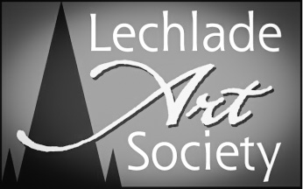

MEMBERSHIP FORM

The annual subscription is £17 and £28 double (living at the same address) due on 1st June of each year. Please make cheques payable to Lechlade Art Society and post to:

Vedanti Moodley (LAS Membership Secretary)
9 Harvest Crescent
Shilton Park
Carterton
Oxfordshire
OX18 1FF

Please include a stamp to cover the postage of your ‘Annual Programme of Events’ or pick up card at AGM.

Visit website: www.lechladeartsociety.com for further information. Follow us on:
Facebook: https://www.facebook.com/LechladeArtSociety
Twitter: @LechladeArtSoc

NAME/S: ………………………………………………………………………………………………………………….
TELEPHONE: ……………………………………………………………………………………………………………
EMAIL: ………………………………………………………………………………………………………………..…..
ADDRESS: …………………………………………………………………………………………………………….…
……………………………………………………………………………………………………………………..………
…………………………………………………………………………………………………………………………..…
POSTCODE: ………………………………………………..

I / We enclose cheque for sum of £….........

DATE: …………………………… SIGNATURE/s …………………………………………………………………...

I/We are interested in: (Please tick the relevant box)

Watercolour | Acrylic | Oil | Line & Wash | Pastels
Workshops | Beginners Classes | Painting on location | Exhibitions | Lectures in Art
Monoprinting | Life Drawing | OTHER:

